Final Report: Lack of Education among Low-Income Communities

Student’s Name:

Institutional Affiliation:

Course:

Tutor:

Date:

Table of Contents
Lack of Education among Low-Income Communities iii
Letter of Transmittal iii
Executive Summary v
Introduction 1
Background 2
Literature Review 4
Proposed Solution 6
Expected Benefits 8
Conclusion 9
References 10

Lack of Education among Low-Income Communities

Letter of Transmittal

Dear Governor Andrew Cuomo:

I present to you this report on the status of education access and impact among low-income communities in your state of New York. The report will show the challenges that are faced by low-income communities in accessing high-quality education along with the impacts. It will also show the possibilities that will arise from the collaboration of the government and potential partners (businesses and non-governmental organizations), in the provision of quality education for individuals from low-income communities. By reading this report, you will find a proposed solution that will not only be effective in solving the challenge in New York, but also in the entire United States.
Evidence has shown that individuals from low-income communities do not have equal access to education like others. They have to choose between going to school or looking for a source of livelihood to access basic needs such as food, clothes, and shelter. For individuals that succeed to go to school, they face many barriers such as unqualified teachers, limited resources, and lack of money to buy essential items such as books. Such challenges do not only lead to individuals dropping out of school, but also increases poverty as they do not have the qualifications for employment.
Therefore, this report proposes two solutions that will increase funding for education for individuals from low-income communities. The first solution is to increase funding to support education in low-income communities. The second solution is for the government to collaborate with businesses and non-governmental organizations to increase funding.
By reading this report and the proposed solution, you will find more details on the implementation process and the resulting benefits for low-income communities, businesses, non-governmental organizations, and the entire state.
Thank you
(Insert name here)

Executive Summary
The purpose of this report is to provide a proposal for increasing education funding in low-income communities in New York. Individuals from low-income communities in New York have had unequal access to education opportunities due to poverty and poor-quality education. As a result of this, they have not had equal employment opportunities, and this has led to an increased cycle of poverty that affects the whole state. The report has provided solutions for addressing this problem and it includes increasing state funding for education in low-income communities and collaborating with businesses and non-governmental organizations to increase support for more students from low-income communities. The report highlights some of the benefits that will be realized and they include:
- Equal access to education and employment opportunities
- More qualified individuals to be employed in businesses and non-governmental organizations
- Reduction of poverty
- Improved socio-economic status

Introduction
Education is an important aspect of any individual’s life as it impacts the quality and standard of living in society. It is for this reason that this report provides a proposal to the state government of New York on increasing education access and funding among low-income communities. Individuals from low-income communities do not have an equal opportunity in accessing education. They have to decide on whether to use the little they have to get an education or provide basic needs. In most cases, the latter usually wins. For those that choose to get an education, still get a low-quality one due to challenges such as unqualified teachers and lack of educational materials. This has prevented individuals from low-income communities from getting the knowledge and skills required for employment. The result has been an endless cycle of poverty that affects the whole state. Based on this, the report is aimed at suggesting solutions for increasing funding. One significant solution is enhancing the collaboration between the government and businesses and non-governmental organizations, to contribute to the economic growth of the state.

Background
Education disparities have existed in New York and the United States for many years. The sad truth is that educational opportunities and the possibility of succeeding for students are dependent on the level of family income, and the community in which they reside (The City University of New York, n. d.). Individuals from higher-income communities (such as Upper East Side) have more opportunities for education as opposed to those from low-income communities (such as South Bronx). Apart from this, individuals from high-income communities have more access to educational resources such as qualified teachers and learning materials. Evidence has shown that a large number of bright students from low-income communities in New York have not had the opportunity to take exams for gifted programs (The City University of New York, n. d.). Worst of all, many schools in low-income communities do not have effective education programs. In higher education, underfunding of educational programs, limited financial aid, and the high cost of programs have contributed to the lack of education among individuals from low-income communities (Smith, 2013). While many of such students strive to get into college, staying becomes the biggest challenge. Therefore, poverty and education are highly related. The graph below shows how missing school due to poverty can affect the performance of students.
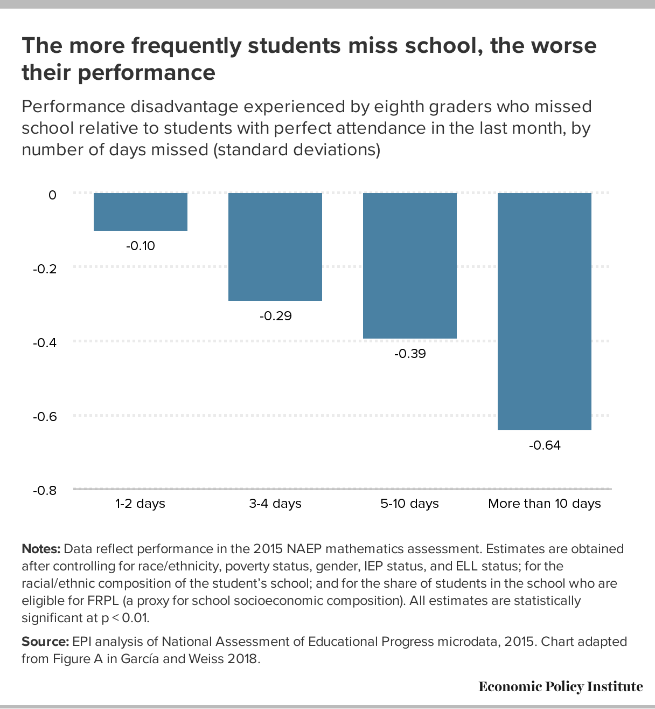

Literature Review
Evidence has shown the relationship that exists between poverty and education. Quillian (2017) indicates that poor neighborhoods create the disadvantage that is experienced by residents in accessing education. Apart from this, poor neighborhoods are characterized by reduced adult earnings and limited educational attainment. Quillian (2017) indicates that such poor neighborhoods are inhabited by minority groups such as African Americans and Latinos. The author goes on to indicate that the effect of poor neighborhoods causes more harm to children than adults. A report by the US Department of Education (n. d.) indicates that individuals who fail to attend or drop out of college are from low-income communities, and live in underdeveloped areas. The department's report goes on further to state that students who succeed in getting into college, attend institutions that are undercapitalized and underdeveloped. This leads to lower graduation rates. The image below shows how the lack of resources affects students from low-income communities.
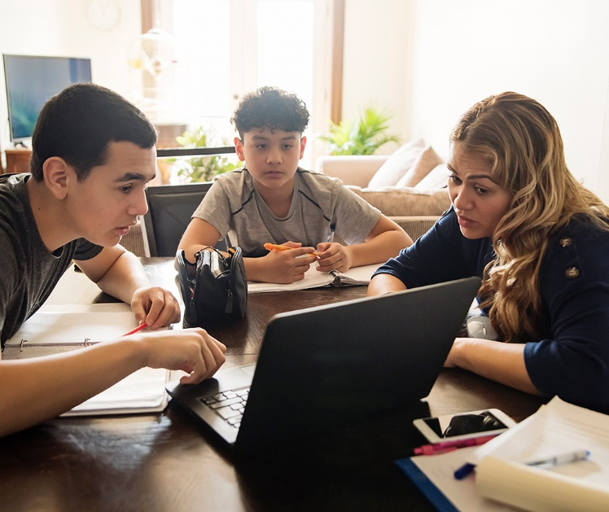Source: RTI International
According to the National Association of School Principals (n. d.), poverty impedes the ability of students to succeed. This report indicates that from 2015-2016, 25% of students were enrolled in high poverty schools. Out of this, 19% lived in extreme poverty. The report indicates that students from poor families do not have enough resources to study, complete their homework, or engage in activities that improve academic success. For example, most of them lack internet in the era of the coronavirus, when remote learning has been adopted. Apart from this, schools in high-poverty areas lack essential learning resources.

Proposed Solution
Two main recommendations can be implemented to solve this challenge that is affecting the potential of the community. The first solution is increasing education funding in low-income communities. The New York State Commissioner of Education should work with the government to review the state funding formulas (New York State Education Department, n. d.). This review can ensure that there is a balancing of funds so that it is equally shared among all the districts, and with regard to the level of poverty. In increasing access to funds, the government should prioritize strategies aimed at improving community schools (New York State Education Department, n. d.). For example, more funds should be provided for addressing the barriers to education that result from poverty.
The provision of financial aid is another factor to be considered in increasing funding for education. The provision of financial aid should not be based on merit but the level of need in the different school districts (New York State Department of Education, n. d.). For the district leaders, they should ensure that more funding is directed to low-income students to ensure that they have an equal chance of accessing education. District funding decisions should be based on the use of per-pupil expenditure data. Apart from this, funding should be provided for increasing training in high-poverty schools.
The second solution is enhancing collaboration with businesses and non-governmental organizations. There are many businesses and non-governmental organizations that are already supporting education or are willing to do so. Some of them include the Children's Scholarship Fund, Cambodian Community Dream Organization, International Education and Resource Network, and the National School Climate among others. Companies such as JP Morgan Chase, Verizon Communications, Pfizer, and Morgan Stanley have the potential of providing grants for supporting education in low-income communities. Such businesses and organizations can fund different aspects of education through sponsorship, upgrading of facilities, provision of basic needs for students, and provision of employment for families with students in school among others. Doing this provides the opportunity to impart knowledge and skills to more people.

Expected Benefits
The proposed solution is expected to result in different benefits. For students, they will have equal access to education opportunities irrespective of their background. They will also have the opportunity to get a quality education that can improve their quality of life. For families in low-income communities, they will get an equal opportunity for employment if they have the right knowledge and skills. They will not have to choose between providing basic needs and getting an education. For businesses and non-governmental organizations, they will get more qualified individuals to employ in their different job positions. They will get the first opportunity in seeking fresh graduates from different institutions. Apart from this, high incomes will mean more consumption for businesses. For the government, the reduction in the level of poverty will improve the living standards. As more people are educated and employed, they will contribute to the economic development of the state and the country.

Conclusion
Lack of education among low-income communities is a major problem that has not only been caused by poverty, but has also increased poverty levels. Students from low-income families have unequal access to education due to the background and the nature of their communities. The result of this has been a continuous cycle of poverty. The government should not only increase education funding to solve this problem, but also collaborate with businesses and non-governmental organizations to support more students. It will ensure that there is no discrimination in education. It will provide more opportunities for employment and spending. It will also boost economic growth as more people move out of poverty.

References
City University of New York (n. d.). Income inequality and education in NYC.
https://blogs.baruch.cuny.edu/inequalitynyc/?page_id=17
National Association of Secondary School Principals (n. d.). Poverty and its impact on students’
education. https://www.nassp.org/poverty-and-its-impact-on-students-education/
New York State Education Department (n. d.). About the New York State Education
Department. http://www.nysed.gov/about
Quillian, L. (2017). Poverty, neighborhood, and school setting. Focus 33(2); 22-28.
Smith, K. (2013). How poverty impacts student success in higher education. New York State
United Teachers.
US Department of Education (n. d.). Low-income minority students.
https://www2.ed.gov/offices/OPE/AgenProj/report/theme1a.html

